
P. R. POTE PATIL
College of Engineering & Management, Amravati.

DEPARTMENT OF ARTIFICIAL INTELLIGENCE & DATA SCIENCE

Year: 2025-26 Semester: IV

Course: Artificial Intelligence and Data Science

Institute Vision Mission
Vision
To flourish as a center of excellence for producing the skilled technocrats and committed human beings.
Mission
- To create conducive environment for teaching &learning.
- To impart quality education through demanding academic programs.
- To enhance career opportunities by exposure to Industries & recent technologies.
- To develop professionals with strong ethics and human values for the betterment of society.

Department of Artificial Intelligence & Data Science

Vision
To achieve excellence in education, research & innovation for steering ethical, impactful, and globally competitive engineers

Mission
- To provide academic excellence, ensuring students equipped with cutting-edge knowledge and skills.
- To promote a vibrant research ecosystem encouraging faculties and students contributing to the advancement of knowledge and innovation.
- To inculcate ethical values and a sense of responsibility in students and preparing them to be ethical leaders who prioritize societal well-being and equity.

Program Outcomes:
PO1: Engineering Knowledge: Apply knowledge of mathematics, natural science, computing, engineering fundamentals and an engineering specialization as specified in WK1 to WK4 respectively to develop to the solution of complex engineering problems.
PO2: Problem Analysis: Identify, formulate, review research literature and analyze complex engineering problems reaching substantiated conclusions with consideration for sustainable development. (WK1 to WK4)
PO3: Design/Development of Solutions: Design creative solutions for complex engineering problems and design/develop systems/components/processes to meet identified needs with consideration for the public health and safety, whole-life cost, net zero carbon, culture, society and environment as required. (WK5)
PO4: Conduct Investigations of Complex Problems: Conduct investigations of complex engineering problems using research-based knowledge including design of experiments, modelling, analysis &amp; interpretation of data to provide valid conclusions. (WK8)
PO5: Engineering Tool Usage: Create, select and apply appropriate techniques, resources and modern engineering &amp; IT tools, including prediction and modelling recognizing their limitations to solve complex engineering problems. (WK2 and WK6)
PO6: The Engineer and The World: Analyze and evaluate societal and environmental aspects while solving complex engineering problems for its impact on sustainability with reference to economy, health, safety, legal framework, culture and environment. (WK1, WK5, and WK7)
PO7: Ethics: Apply ethical principles and commit to professional ethics, human values, diversity and inclusion; adhere to national &amp; international laws. (WK9)
PO8: Individual and Collaborative Team work: Function effectively as an individual, and as a member or leader in diverse/multi-disciplinary teams.
PO9: Communication: Communicate effectively and inclusively within the engineering community and society at large, such as being able to comprehend and write effective reports and design documentation, make effective presentations considering cultural, language, and learning differences.
PO10: Project Management and Finance: Apply knowledge and understanding of engineering management principles and economic decision-making and apply these to one’s own work, as a member and leader in a team, and to manage projects and in multidisciplinary environments.
PO11: Life-Long Learning: Recognize the need for, and have the preparation and ability for independent and life-long learning ii) adaptability to new and emerging technologies and iii) critical thinking in the broadest context of technological change. (WK8)

Program Educational Objectives (PEO):

To prepare the Engineering graduates to

PEO1: Technical Proficiency: Graduates will demonstrate proficiency in core areas of computer science, including algorithms, data structures, software engineering, and database systems, with a specialized focus on artificial intelligence and data science techniques.
PEO2: Leadership and Innovation: Graduates will exhibit leadership qualities and innovative thinking, contributing to the development and implementation of AI-driven solutions that address societal, industrial, and environmental challenges.
PEO3: Ethical and Professional Responsibility: Graduates will adhere to ethical and professional standards in their engineering practice, demonstrating integrity, accountability, and a commitment to societal well-being in the design and deployment of AI and DS systems.
PEO4: Lifelong Learning: Graduates will adopt a culture of lifelong learning and professional development, empowering individuals to adapt to emerging technologies, navigate complex socio-technical landscapes, and contribute meaningfully to the advancement of AIDS throughout their careers.

Program Specific Outcome (PSO):
PSO1: Apply Intelligent Systems Development: Develop intelligent systems and applications integrating AI and DS technologies to enhance functionality and performance.
PSO2: Problem-Solving Skills: Possess strong analytical and problem-solving skills, enabling them to identify, formulate, and solve complex engineering problems using AI and DS methodologies in diverse application domains.y

GUIDELINES FOR TEACHERS

Teachers shall discuss the following points with students before start of practical of the subject.

- Learning Overview: To develop better understanding of importance of the subject. To know related skills to be developed such as intellectual and motor skills.
- Know you’re Laboratory Work: To understand the layout of laboratory, specifications of equipment / instruments /materials, procedure, working in groups, planning time etc. also to know total amount of work to be done in the laboratory.
- Teacher shall ensure that required equipment is in working condition before start of each experiment, also keep operating instruction manual available.
- Explain prior concepts to the students before starting of each experiment.
- Evolve student’s activity at the time of conduct of each experiment.
- While taking reading / observation each student (from batch of 20 students) shall be given a chance to perform / observe the experiment.
- Teacher shall assess the performance of students continuously.
- Teacher is expected to share the skills to be developed in the students.
- Teacher should ensure that the respective skills are developed in the students after the completion of the practical exercise.
- Teacher may provide additional knowledge and skills to the students even though not covered in the manual but are expected from students by the industries.
- Teacher may suggest the students to refer additional related literature of the technical papers / reference books / Seminar Proceedings, etc.
- Focus should be given on development of enlisted skills rather than theoretical / codified knowledge.
- During assessment teacher is expected to ask questions to the students to tap their achievements regarding related knowledge and skills.
- Teacher should give more focus on hands on skills.
INSTRUCTIONS FOR STUDENTS
- Students shall read the points given below for understanding the theoretical concepts and practical applications.
- Listen carefully to the lecture given by teacher about importance of subject, curriculum philosophy, learning structure, skills to be developed, information about equipment, instruments, procedure, method of continuous assessment, tentative plan of work in laboratory and total amount of works to be done in a semester.
- Student shall undergo study visit of the laboratory for types of equipment, and material to be used, before performing experiments.
- Read the write up of each experiment to be performed, a day in advance.
- Organize the work in the group and make a record of all observations.
- Understand the purpose of experiment and its practical implications.
- Student should not hesitate to ask any difficulty faced during conduct of practical /exercise.
- Write the answers of the questions allotted by the teacher during practical hours if possible or afterwards, but immediately.
- Student should develop the habit of pear discussion / group discussion related to experiments / exercise so that exchanges of knowledge / skills could take place.
- Students shall attempt to develop related hands-on-skills and gain confidence.
- Student shall focus on development of skills rather than theoretical or codified knowledge.
- Student shall insist for the completions of recommended Laboratory Work, answers to the given question etc.
- Student shall develop the habit of evolving more ideas, innovations, skills etc. that included in the scope of the manual.
- Student shall refer technical magazines, proceedings of the Seminars, refer website related to the scope of the subjects and update their knowledge and skills.
- Student should develop the habit of not depend totally on teachers but to develop self-learning techniques.
- Student should develop the habit to interact with the teacher without hesitation with respect to academic involved.
- Student should develop habit to submit the practical’s exercise continuously and progressively on the schedule dates and should get the assessment done.
- Student should be well prepared while submitting the write up of the exercise. This will develop the continuity of the studies and he will not be overloaded at the end of the term.

P. R. POTE PATIL
COLLEGE OF ENGINEERING & MANAGEMENT, AMRAVATI.

DEPARTMENT OF ARTIFICIAL INTELLIGENCE & DATA SCIENCE

Certificate

This is to certify that Mr./Ms…………………………………………... of IV Semester of Bachelor of Technology in Artificial Intelligence & Data Science of P. R. Pote Patil College of Engineering & Management, Amravati, has completed the term work satisfactory of course Artificial Intelligence & Data Science for the academic year 2025 - 2026 as prescribed in the curriculum.

Date………………… | Roll No……………………

Subject Teacher | Head of the Department

LIST OF (PRACTICALS / EXPERIMENTS )& PROGRESSIVE ASSESSMENT FOR TERM WORK
Academic Year :2025-26 | Course: Artificial Intelligence and Data Science
Course Code: AI407PCC10 | Semester: IV
Name of Faculty: Dr P G Angaitkar
Name of Student: ………………………………………
Roll No………………………………
SN. | Title of the  Practical / Experiment | Date of Performance | Date of Submission | Sign of Teacher
1 | To implement a Tic-Tac-Toe game where the AI plays optimally against a human.
2 | To Demonstrate Non-Monotonic Reasoning by implementing logic-based reasoning with exceptions (e.g., default reasoning) in python
3 | To represent real-world knowledge using Semantic Networks and perform inference (relationship reasoning) among entities using Python.
4 | To solve a path finding problem using the A* algorithm and visualize the search process on a graph
5 | To solve a constraint satisfaction problem (e.g., Sudoku or N-Queens) using Python libraries or custom logic in python
6 | To implement the AO* (AND-OR Graph) algorithm for solving problem reduction tasks.
7 | Load and explore a real-world dataset (CSV format), understand its structure, and summarize key statistics in Python
8 | To perform a data cleaning technique such as handling missing values, encoding categorical variables, and scaling/normalizing data
9 | To perform EDA on a dataset by calculating descriptive  Statistics and visualizing the data using python libraries.
10 | To compute and interpret statistical measures such as mean, median, mode, range, variance, standard deviation, and interquartile range using Python libraries
11 | To perform data visualization using Box Plot to analyze data distribution and detect outliers in Python
12 | To compute skewness and kurtosis to understand the shape of data distribution and visualize the distribution using histogram and density plot.

Signature of Faculty
Course Outcomes
After successful completion of laboratory course, the students will able to
SN | Outcomes
 | After successful completion of this course, students will be able to
1 | Understand different AI-based algorithmic design strategies
2 | Analyze the efficiency of algorithms using time complexity.
3 | Analyze and implement the different statistical techniques on various types of data
Rubrics used for continuous Assessment in every lab session
Skills | Allocated Marks | High | Medium | Low
 |  | 10-08 | 07-04 | 03-00
Process Related Skills | 10 | Student performed or executed experiments, obtained results, and drew conclusions fully as per expectation  within a due date. | Student performed or executed experiments, obtained results, and drew conclusions partially as per expectation after a due date. | Student performed or executed experiments, obtained results, and drew conclusions below the expectation after two weeks of a due date.
Product Related Skills | 10 | 10-08 | 07-04 | 03-00
 |  | Records submitted by the student on due date and found highly satisfactory after evaluation. | Records submitted by the student after one wee+k of due date and found moderately satisfactory after evaluation. | Records submitted by the student after two week of due date and found highly dissatisfactory after evaluation.
Viva Voce | 05 | Student answered the Questions satisfactorily. | Student answered the Questions moderately satisfactorily. | Student did not answer the Questions.
Total Marks for Lab Performance 25 Marks
Rubrics used for External Assessment in lab course
Skills | Allocated Marks | Parameters | High | Medium | Low
Process Related Skills | 15 | Handle equipment/ tools/ commands correctly or logic formation and Work cohesively in team (7) | Most satisfactory (6-7) | Partially successful (4-5) | Below expectation (0-3)
 |  | Integrate system correctly & measure parameters correctly or Debugging Ability (8) | Highly satisfactory (7-8) | Partially correct (5-6) | Incorrect or unsatisfactory (0-4)
Product Related Skills | 10 | Obtain correct results, Answer practical related questions (5) | Exceptional (4-5) | Satisfactory (3) | Unsatisfactory (0-2)
 |  | Interpret results, draw conclusion (5) | Exceptional (4-5) | Satisfactory (3) | Unsatisfactory (0-2)
Total Marks |  | 25 Marks
EXPERIMENT NO: 01

Aim: Implement a Tic-Tac-Toe game where the AI plays optimally against a human using the minimax algorithm.

Software Used: Jupyter Notebok

Theory: Tic-Tac-Toe is a two-player game played on a 3x3 grid, where players alternately mark X or O in an empty cell. The objective is to form a straight line (horizontal, vertical, or diagonal) of three marks. The minimax algorithm is a decision-making algorithm used in game theory and AI to minimize the possible loss for a worst-case scenario while maximizing the potential gain. In this experiment, the minimax algorithm evaluates all possible moves by the player and the AI, assigns scores based on the game outcome, and selects the move that maximizes the AI's chance of winning or results in a draw. This ensures the AI always plays optimally

Code:

board = [' ']*9
def print_board():
print()
print(f" {board[0]} | {board[1]} | {board[2]} ")
print("---+---+---")
print(f" {board[3]} | {board[4]} | {board[5]} ")
print("---+---+---")
print(f" {board[6]} | {board[7]} | {board[8]} ")
print()
def check_winner(symbol):
winning_positions = [
(0,1,2), (3,4,5), (6,7,8),
(0,3,6), (1,4,7), (2,5,8),
(0,4,8), (2,4,6)
]
for a, b, c in winning_positions:
if board[a] == board[b] == board[c] == symbol:
return True
return False

def check_draw():
return ' ' not in board

def player_move(symbol):
move = int(input(f"Player {symbol}, enter position (1-9): ")) - 1

if board[move] == ' ':
board[move] = symbol
else:
print("That spot is already taken!")
player_move(symbol)
def play_game():
current_player = 'X'
print_board()

while True:
player_move(current_player)
print_board()

if check_winner(current_player):
print(f"Player {current_player} wins!")
break

if check_draw():
print("It's a draw!")
break

if current_player == 'X':
current_player = 'O'
else:
current_player = 'X'

play_game()

Output:

this is its output :

| |
---+---+---
| |
---+---+---
| |

Player X, enter position (1-9): 1

X | |
---+---+---
| |
---+---+---
| |

Player O, enter position (1-9): 2

X | O |
---+---+---
| |
---+---+---
| |

Player X, enter position (1-9): 3

X | O | X
---+---+---
| |
---+---+---
| |
Player O, enter position (1-9): 4

X | O | X
---+---+---
O | |
---+---+---
| |

Player X, enter position (1-9): 5

X | O | X
---+---+---
O | X |
---+---+---
| |

Player O, enter position (1-9): 6

X | O | X
---+---+---
O | X | O
---+---+---
| |

Player X, enter position (1-9): 7
X | O | X
---+---+---
O | X | O
---+---+---
X | |
Player X wins!

Conclusion: Hence I implemented Tic Tac Toe game in python successfully.

Signature of Faculty

EXPERIMENT NO: 02

Title: To Demonstrate Non-Monotonic Reasoning by implementing logic-based reasoning with exceptions (e.g., default reasoning) in python

Objective: To understand and implement non-monotonic reasoning in Artificial Intelligence by demonstrating how conclusions can change when exceptions are introduced using default reasoning rules in Python.

Software Required: Jupyter Notebook

Theory:
Non-monotonic reasoning is a form of logical reasoning where conclusions can be withdrawn when new information is introduced, unlike classical logic where conclusions only grow. This type of reasoning is closer to human thinking because people often draw tentative conclusions based on typical situations and revise them when exceptions appear. Default reasoning is a type of non-monotonic reasoning where general rules (defaults) are used unless contradictory evidence is found. For example, we may assume “birds can fly” unless we learn an exception such as “penguin is a bird but cannot fly.” In this experiment, we implement a simple default reasoning mechanism in Python that updates conclusions when exceptions are added.

Code:

def check_office(day, dm):

if day == "Saturday" or day == "Sunday":
status = "CLOSED"
reason = "it is the weekend"
else:
status = "OPEN"
reason = "it is a weekday"

print(f"Initial Assumption: On {day}, {dm}, the office should be {status}.")

holidays = {
"26/1": "Republic Day",
"15/8": "Independence Day",
"2/10": "Gandhi Jayanti",
"6/12": "Mahaparinirvan Diwas"
}

if dm in holidays:
status = "CLOSED"
reason = f"it is {holidays[dm]}"
print("New information found (Holiday) !!!")

print(f"FINAL DECISION: Office is {status} because {reason}.\n")

da = input("Enter Date : ")
m = input("Enter Month : ")
d = input("Enter Day : ")
date = da + '/' + m

check_office(d, date)

Output :

Outout 1 :

Enter Date : 6
Enter Month : 12
Enter Day : Wednesday
Initial Assumption: On Wednesday, 6/12, the office should be OPEN.
New information found (Holiday) !!!
FINAL DECISION: Office is CLOSED because it is Mahaparinirvan Diwas.

Output 2 ;

Enter Date : 7
Enter Month : 2
Enter Day : Friday
Initial Assumption: On Friday, 7/2, the office should be OPEN.
FINAL DECISION: Office is OPEN because it is a weekday.

Output 3 :

Enter Date : 5
Enter Month : 4
Enter Day : Saturday
Initial Assumption: On Saturday, 5/4, the office should be CLOSED.
FINAL DECISION: Office is CLOSED because it is the weekend.

Conclusion:
This experiment demonstrates non-monotonic reasoning where earlier conclusions can be modified when new evidence (exceptions) is introduced. Using default reasoning rules allows AI systems to model real-world knowledge more naturally, where defaults such as “birds can fly” hold unless specific exceptions exist.

Signature of Faculty
EXPERIMENT NO: 03

Title: To represent real-world knowledge using Semantic Networks and perform inference (relationship reasoning)among entities using Python

Objective: To represent real-world knowledge using Semantic Networks and perform inference by identifying relationships such as is-a, part-of, and property among entities in Python.

Software Required: Jupyter Notebook

Theory:

A semantic network is a graphical knowledge representation technique where concepts (nodes) are connected by relationships (edges). These networks represent real-world knowledge in the form of objects, categories, and their properties using relations such as is-a, has-a, or part-of. Semantic networks support inheritance, allowing a concept to inherit attributes from a parent category, similar to object-oriented programming. This helps in inference, where new facts can be derived — for example, if a “parrot” is-a “bird,” and birds can fly, then one can infer that a parrot can fly. In this experiment, a semantic network is created in Python, and reasoning is performed to infer relationships among entities.

Code:

books = {
"Book" : {
"written by" : None,
"price" : [None,None]
},
"Kavya Phule": {
"written by": "Savatribai Phule",
"price": ["₹450 to ₹550", "Shree Ram Book Stall, Amravati"]
},
"Train to Pakistan": {
"written by": "Khushwant Singh",
"price": ["₹199 to ₹250", "Gajanan Book Stall,Amravati"]
},

"Annihilation of Caste": {
"written by": "Dr. B.R. Ambedkar",
"price": ["₹149 to ₹199", "Maitri Book Depo Amravati"]
},

"Gulamgiri (Slavery)": {
"written by": "Mahatma Jyotirao Phule",
"price": ["₹120 to ₹180", "Maitri Book Depo Amravati"]
}
}

def get_book_details(book_name):
if book_name not in books:
return None

details = books[book_name]
author = details["written by"]
price_range = details["price"][0] # Taking the first string in the list
stall = details["price"][1]
return f"Written by {author}, Price: {price_range}, Available at {stall}"

def infer(book_name):
details = get_book_details(book_name)
if not details:
return f"No information available for '{book_name}'."

return f"{book_name} properties (inferred): {details}"

# Corrected the spelling of "Annihilation" in the list below
pustak = ["Gulamgiri (Slavery)", "Annihilation of Caste", " to Pakistan","Book"]

for b in pustak:
print(infer(b))

Output:

Gulamgiri (Slavery) properties (inferred): Written by Mahatma Jyotirao Phule, Price: ₹120 to ₹180, Available at Maitri Book Depo Amravati
Annihilation of Caste properties (inferred): Written by Dr. B.R. Ambedkar, Price: ₹149 to ₹199, Available at Maitri Book Depo Amravati
No information available for ' to Pakistan'.
Book properties (inferred): Written by None, Price: None, Available at None

Conclusion:
This experiment demonstrates how semantic networks provide an intuitive way to represent and infer real-world knowledge. By using inheritance, entities automatically acquire properties from their parent categories, enabling efficient relationship reasoning.

Signature of Faculty
EXPERIMENT NO: 04

Title: To solve a path finding problem using the A* algorithm and visualize the search process on a graph
Objective: To implement the A* pathfinding algorithm in Python and visualize the search process on a grid-based graph to understand how heuristic-driven search efficiently finds the optimal path.

Theory:

The A* (A-star) algorithm is an informed search technique used for finding the shortest path between two points in a graph. It uses both the actual cost from the start node (g-cost) and an estimated cost to the goal (h-cost) using a heuristic function, usually the Manhattan or Euclidean distance. By combining these costs (f = g + h), A* expands nodes in an optimal order, making it more efficient than uninformed search algorithms like BFS or uniform cost search. A* guarantees optimality if the heuristic is admissible (never overestimates). In this experiment, we simulate a grid, apply A*, and visualize the nodes explored during the search.

Code:

import numpy as np
import matplotlib.pyplot as plt
from heapq import heappush, heappop

grid = np.zeros((8, 8)) # 8x8 chi Grid
grid[2, 1:6], grid[5, 2:7] = 1, 1 # Obstacles (1 = wall)
start, goal = (0, 0), (4, 6) # Start at top left and goal at middle right.

def a_star(grid, start, goal):
h = lambda p: np.linalg.norm(np.array(p) - goal)
# np.linalg.norm calculates the Eucledine dist. Directly.
pq, visited = [(h(start), 0, start, [])], set()

while pq:
f, g, node, path = heappop(pq)
# (f_value, g_value, current_position, path_until_now)
if node in visited:
Continue # Skips already explored Nodes.
visited.add(node) #Adds newly visited nodes.
path = path + [node]

if node == goal:
return path, visited

for dr, dc, w in [(0,1,1), (0,-1,1), (1,0,1), (-1,0,1), # sides
(1,1,1.41), (1,-1,1.41), (-1,1,1.41), (-1,-1,1.41)]: # diagonals
r, c = node[0] + dr, node[1] + dc
if 0 <= r < 8 and 0 <= c < 8 and grid[r, c] == 0:
heappush(pq, (g + w + h((r, c)), g + w, (r, c), path))

# Get path and Explored Nodes.
path, explored = a_star(grid, start, goal)

# Visualization
plt.figure(figsize=(6, 6))
plt.imshow(grid, cmap="gray_r")

# Plot Explored (Cyan) and Final Path (Red)
for r, c in explored:
plt.plot(c, r, 'co', markersize=4)
for r, c in path:
plt.plot(c, r, 'ro-', markersize=6)

# Markers for Start and Goal
plt.plot(start[1], start[0], 'gs', label="Start")
plt.plot(goal[1], goal[0], 'bs', label="Goal")

plt.title("A* Search: Diagonal Movement")
plt.legend()
plt.grid(True)
plt.show()

print(f"Path: {path}")

Output:
Path: [(0, 0), (0, 1), (0, 2), (0, 3), (0, 4), (1, 5), (2, 6), (3, 6), (4, 6)]

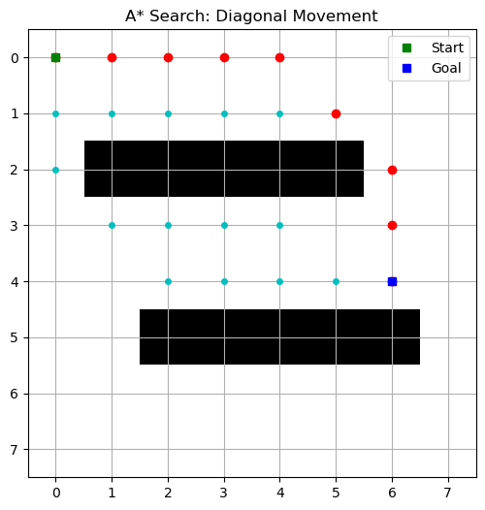

Conclusion:
The A* algorithm successfully finds the shortest path by combining actual movement cost and heuristic estimation. The visualization clearly shows how A* focuses its search toward the goal, exploring fewer nodes than uninformed search methods

Signature of Faculty
EXPERIMENT NO: 05

Title: To solve a constraint satisfaction problem (e.g., Sudoku or N-Queens) using Python libraries or custom logic in python

Objective: To understand and implement Constraint Satisfaction Problem (CSP) solving techniques by applying custom logic in Python to solve the N-Queens puzzle efficiently.

Software Required: Jupyter Notebook

Theory:
Constraint Satisfaction Problems (CSPs) consist of a set of variables, each with possible values, and a set of constraints defining allowable combinations of values. CSPs are widely used in scheduling, planning, resource allocation and puzzle solving. The N-Queens problem is a classical CSP where N queens must be placed on an N×N chessboard such that no two queens attack each other—meaning no two queens share the same row, column, or diagonal. CSPs can be solved using techniques like backtracking, forward checking, and heuristics. In this experiment, a backtracking approach is used to systematically explore valid queen placements and find a solution.
Code:
# this is Practical Number 5 of AI&DS
def is_safe(board, row, col, n):
for i in range(n):
if board[i] != -1 and i != row:
if board[i] == col:
return False
if abs(i - row) == abs(board[i] - col):
return False
return True

def solve_iterative(n, fixed_row, fixed_col):
board = [-1] * n
board[fixed_row] = fixed_col
col_choices = [0] * n
row = 0
while row < n:
if row == fixed_row:
row += 1
continue
found = False
for col in range(col_choices[row], n):
if is_safe(board, row, col, n):
board[row] = col
col_choices[row] = col + 1
found = True
break
if found:
row += 1
else:
col_choices[row] = 0
board[row] = -1
row -= 1
while row == fixed_row:
row -= 1

if row < 0:
return None

return board
def print_board(board, n):
for i in range(n):
for j in range(n):
if board[i] == j:
print("Q", end=" ")
else:
print(".", end=" ")
print()
# -------- MAIN PROGRAM --------
try:
want = int(input("How many Outputs you want: "))
i = 0
while i < want:
try:
print(f"\n--- Run {i + 1} ---")
n = int(input("Enter value of N: "))
f_row = int(input("Enter row for first queen (0-indexed): "))
f_col = int(input("Enter column for first queen (0-indexed): "))

if f_row >= n or f_col >= n or f_row < 0 or f_col < 0:
print("Invalid initial position!")
else:
result_board = solve_iterative(n, f_row, f_col)

if result_board:
print("\nSolution (Iterative):")
print_board(result_board, n)
else:
print("No solution exists with this initial position.")
i += 1 # Only increment if input was processed
except ValueError:
print("Invalid input. Please enter integers.")
except ValueError:
print("Please enter a valid number for total outputs.")
-----------------------------------+++++++--------------------------------------------
Code of Sudoku :
def show_board(board):
print("+-------+-------+-------+")
for i in range(9):
print("|", end=" ")
for j in range(9):
val = board[i][j] if board[i][j] != 0 else "."
print(val, end=" ")
if (j + 1) % 3 == 0:
print("|", end=" ")
print()
if (i + 1) % 3 == 0:
print("+-------+-------+-------+")

def possible(board, r, c):
if board[r][c] != 0:
return []
nums = set(range(1, 10))

nums -= set(board[r]) # row
nums -= {board[i][c] for i in range(9)} # column
# box
br, bc = (r//3)*3, (c//3)*3
nums -= {board[i][j] for i in range(br, br+3) for j in range(bc, bc+3)}
return list(nums)

def solve_logic(board):
changed = True
while changed:
changed = False
for r in range(9):
for c in range(9):
if board[r][c] == 0:
p = possible(board, r, c)
if len(p) == 1:
board[r][c] = p[0]
changed = True
return board

# Sudoku board
board = [
[5,3,0,0,7,0,0,0,0],
[6,0,0,1,9,5,0,0,0],
[0,9,8,0,0,0,0,6,0],
[8,0,0,0,6,0,0,0,3],
[4,0,0,8,0,3,0,0,1],
[7,0,0,0,2,0,0,0,6],
[0,6,0,0,0,0,2,8,0],
[0,0,0,4,1,9,0,0,5],
[0,0,0,0,8,0,0,7,9]
]
solve_logic(board)
show_board(board)

Output:

Output 1 N-Queen :

How many Outputs you want: 2

--- Run 1 ---
Enter value of N: 5
Enter row for first queen (0-indexed): 1
Enter column for first queen (0-indexed): 3

Solution (Iterative):
Q . . . .
. . . Q .
. Q . . .
. . . . Q
. . Q . .

--- Run 2 ---
Enter value of N: 5
Enter row for first queen (0-indexed): 2
Enter column for first queen (0-indexed): 1

Solution (Iterative):
Q . . . .
. . . Q .
. Q . . .
. . . . Q
. . Q . .

Output 2 Sudoku :

+-------+-------+-------+
| 5 3 4 | 6 7 8 | 9 1 2 |
| 6 7 2 | 1 9 5 | 3 4 8 |
| 1 9 8 | 3 4 2 | 5 6 7 |
+-------+-------+-------+
| 8 5 9 | 7 6 1 | 4 2 3 |
| 4 2 6 | 8 5 3 | 7 9 1 |
| 7 1 3 | 9 2 4 | 8 5 6 |
+-------+-------+-------+
| 9 6 1 | 5 3 7 | 2 8 4 |
| 2 8 7 | 4 1 9 | 6 3 5 |
| 3 4 5 | 2 8 6 | 1 7 9 |
+-------+-------+-------+

Conclusion: This experiment demonstrates how constraint satisfaction problems such as the N-Queens puzzle can be efficiently solved using backtracking in Python. By enforcing constraints on rows, columns, and diagonals, the algorithm systematically explores valid queen placements.

Signature of Faculty
EXPERIMENT NO: 06

Title: To implement the AO* (AND-OR Graph) algorithm for solving problem reduction tasks.

Objective: The objective of this experiment is to understand and implement the AO* search algorithm for solving problem-reduction tasks using AND-OR graphs, where problems can be decomposed into smaller subproblems and solved recursively.
Theory:

The AO* algorithm is a best-first search technique used in AND-OR graphs, where nodes may represent decision points (OR nodes) or decomposed subproblems that must all be solved (AND nodes). Unlike traditional algorithms like A*, which work on OR graphs, AO* handles hierarchical problem reduction where solutions may require satisfying multiple child nodes simultaneously. AO* updates node costs recursively using heuristic estimates and selects the best partial solution graph. It is widely used in planning, game trees, problem decomposition frameworks, and reasoning systems.
Program:

import matplotlib.pyplot as plt

graph = {
'A': [('AND', {'B': 3, 'C': 2}), ('OR', {'D': 4})],
'B': [('OR', {'E': 2})],
'E': [('OR', {'G': 0})],
'C': [('OR', {'G': 0})],
'D': [('OR', {'G': 0})]
}

heuristic = {
'A': 7,
'B': 4,
'C': 6,
'D': 5,
'E': 4,
'G': 0
}

def get_path(Node):
if Node not in graph:
return heuristic[Node], [Node]

b_cost = float('inf')
b_path = None

for branch_type, branches in graph[Node]:
if branch_type == 'AND':
pcost = 0
path = [Node]

for branch, wght in branches.items():
bcost, bpath = get_path(branch)
pcost += wght + bcost
path += bpath

else: # OR
pcost = float('inf')
path = None

for branch, wght in branches.items():
bcost, bpath = get_path(branch)
fcost = wght + bcost

if fcost < pcost:
pcost = fcost
path = [Node] + bpath

if pcost < b_cost:
b_cost = pcost
b_path = path

return b_cost, b_path

# Run AO* search
f_cost, f_path = get_path('A')

print("The path cost is:", f_cost)
print("The path is:", " -> ".join(f_path))

# ---------------- GRAPH VISUALIZATION ---------------- #

plt.figure()

# Draw nodes (clean labels)
for node, (x, y) in pos.items():
plt.scatter(x, y)
plt.text(x, y, f"{node}", fontsize=12, ha='center', va='center')

# Draw edges (light lines)
for parent, branches in graph.items():
for branch_type, children in branches:
for child, weight in children.items():
x_values = [pos[parent][0], pos[child][0]]
y_values = [pos[parent][1], pos[child][1]]

# light edge
plt.plot(x_values, y_values, linestyle='--')

# small weight label only
mid_x = (pos[parent][0] + pos[child][0]) / 2
mid_y = (pos[parent][1] + pos[child][1]) / 2
plt.text(mid_x, mid_y, str(weight), fontsize=8)

# Highlight optimal path (clean bold line)
for (u, v) in optimal_path:
x_values = [pos[u][0], pos[v][0]]
y_values = [pos[u][1], pos[v][1]]
plt.plot(x_values, y_values, linewidth=3)

plt.title("AO* Optimal Path")
plt.axis('off') # remove axes for clean look
plt.show()

Output:

The path cost is : 4
The path is: A -> D -> G

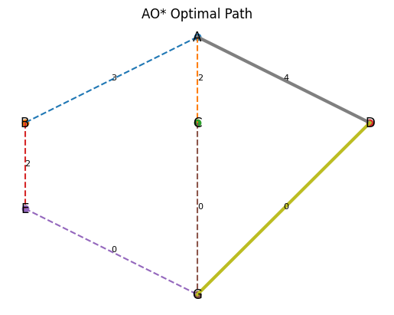

Conclusion: The AO* algorithm successfully identifies the minimum-cost solution in an AND-OR graph by recursively evaluating decomposed subproblems.

Signature of Faculty

EXPERIMENT NO: 07

Title: Load and explore a real-world dataset (CSV format), understand its structure, and summarize key statistics in Python

Objective: The objective of this experiment is to load a real-world dataset in CSV format, understand its structure, and summarize key statistical information such as mean, median, standard deviation, and missing values using Python.

Software Required: Jupyter Notebook

Theory:

Exploratory Data Analysis (EDA) is the first step in any data science workflow and involves loading, understanding, and summarizing a dataset. Using Python libraries like Pandas, NumPy, and Matplotlib, we can inspect a dataset’s structure, identify data types, detect missing values, and compute descriptive statistics. This process helps in understanding data distribution, relationships, and potential preprocessing steps needed for further analysis or model building. CSV files are one of the most common formats for real-world data, and Python provides efficient methods to load and explore them.
Code: -

import pandas as pd
import matplotlib.pyplot as plt

daf = pd.read_csv("result.csv")
daf

print(df.describe())
Print(daf.isnull())

print(daf.info())

print(daf.head())

print(daf.tail())

print(daf.max())

print(daf.min())

print("The overall final percentage of marks : ",daf["Percentage"].mean())

plt.bar(daf['Subject'],df['Percentage'], color="green")

plt.pie(daf["Percentage"], labels=daf['Subject'])

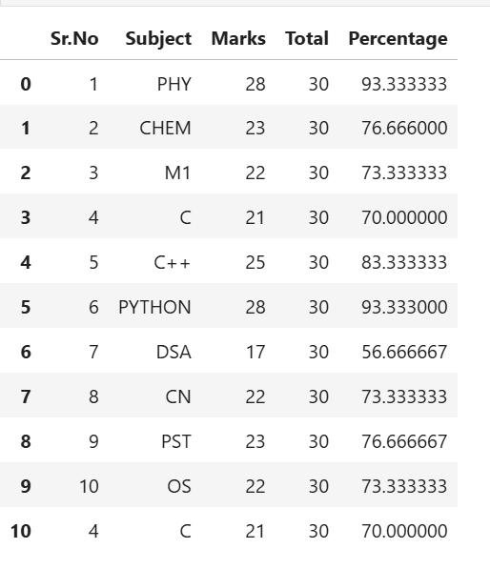
Output: -

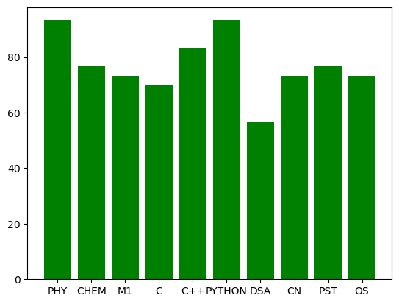

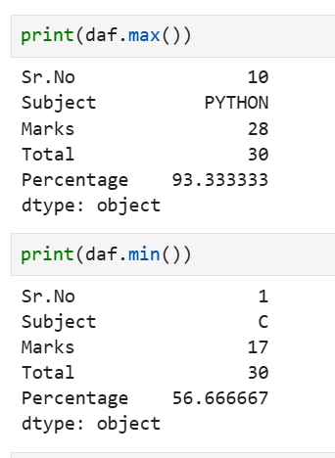

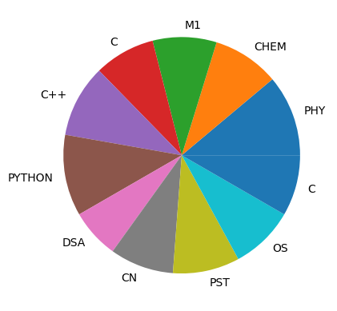

Conclusion: In this experiment, a real-world CSV dataset was loaded using Python’s Pandas library.

Signature of Faculty
EXPERIMENT NO: 08

Title: To perform a data cleaning technique such as handling missing values, encoding categorical variables, and scaling/normalizing data

Objective: The objective of this experiment is to clean a dataset by handling missing values, applying encoding techniques to categorical variables, and performing data scaling or normalization to prepare the dataset for machine learning applications.

Software Required: Jupyter Notebook

Theory:
Data cleaning is an essential preprocessing step in machine learning and data analysis. Real-world datasets often contain missing values, inconsistent formats, and categorical variables that cannot be directly used by algorithms. Handling missing values may involve removing them or replacing them using strategies like mean, median, or mode. Categorical variables must be encoded using techniques such as label encoding or one-hot encoding so they can be processed numerically. Finally, scaling or normalization ensures that numerical features are on a similar scale, improving algorithm performance and convergence. Approaches include Min-Max normalization and Standardization (Z-score scaling). These steps collectively improve the dataset’s quality and usability for model training.
Program: -
import pandas as pd
dat = pd.read_csv('cars.csv')
dat
dat.isnull()

encode = dat.notna().astype(int)
encode # one-hot encoding

dat['launch year'] = dat['launch year'].fillna(dat['launch year'].mean())
dat['price(lakh)'] = dat['price(lakh)'].fillna(dat['price(lakh)'].mean())
dat

from sklearn.preprocessing import LabelEncoder
df = pd.DataFrame(dat)
df

encoder = LabelEncoder()
df["model No."] = encoder.fit_transform(df["model No."])
Df

Output: -
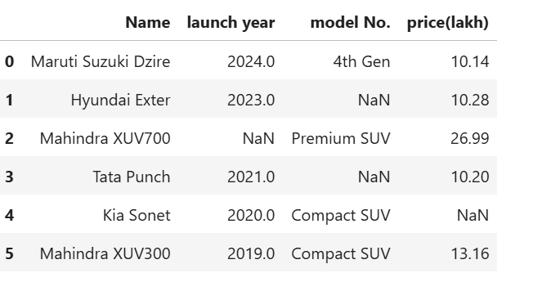

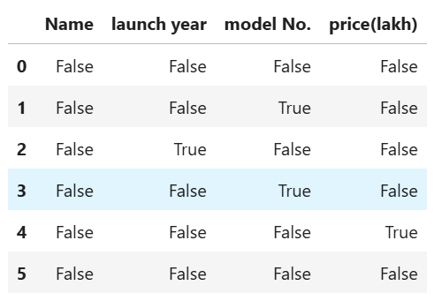
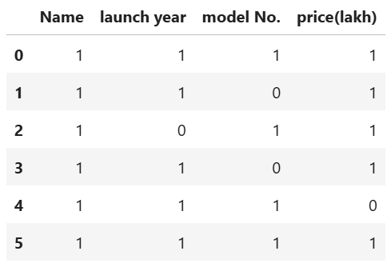

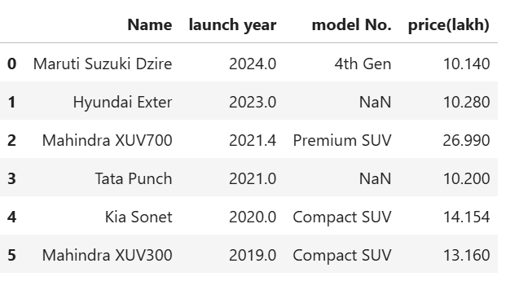

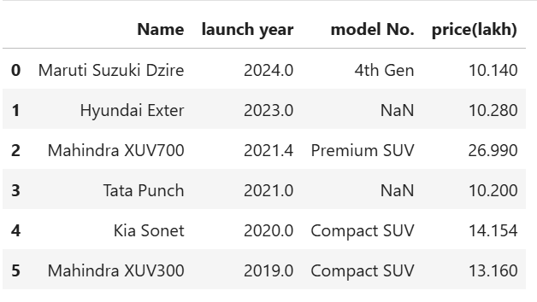

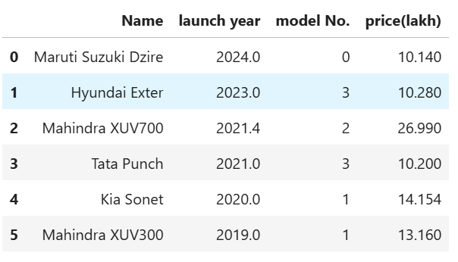

Conclusion: In this experiment, missing values were handled, categorical variables were encoded into numerical format, and data scaling/normalization was applied.

Signature of Faculty

EXPERIMENT NO: 09

Title: To perform EDA on a dataset by calculating descriptive Statistics and visualizing the data using python libraries

Objective: The objective of this experiment is to perform Exploratory Data Analysis (EDA) by computing descriptive statistics and visualizing the dataset using Python libraries to understand data patterns, distribution, and relationships among variables.

Software Required: Jupyter Notebook

Theory:

Exploratory Data Analysis (EDA) is the process of analyzing datasets to summarize their key characteristics using visual and statistical approaches. It helps reveal hidden patterns, detect anomalies, test assumptions, and understand relationships among variables. Descriptive statistics such as mean, median, standard deviation, and variance provide numeric summaries of the data, while data visualization techniques—such as histograms, boxplots, bar charts, and correlation heatmaps—offer intuitive insights into distributions and relationships. Python libraries like Pandas, NumPy, Matplotlib, and Seaborn are commonly used for performing EDA efficiently.
Code: -
import pandas as pd
import matplotlib.pyplot as plt
import seaborn as sns

d1 = pd.read_csv('pr_9_data.csv')
d1.head().info()

# checking if some values are missoing or not
print(d1.isnull().sum())

print("Highest marks scored by whom in which subject : ")
s1 = d1["Maths"].max()
s2 = d1["English"].max()
s3 = d1["Science"].max()
print("Maths : ", s1)
print("Scored by : ",d1[d1["Maths"]==s1]["Student"])
print("English : ",s2)
print("Scored by : ",d1[d1["English"]==s2]["Student"])
print("Science : ",s3)
print("Scored by : ",d1[d1["Science"]==s3]["Student"])

d1[['Maths','Science','English']].hist()
plt.suptitle("Marks Distribution")
plt.show()

plt.figure()
sns.boxplot(d1[['Maths','Science','English']])
plt.title("Boxplot of Marks")
plt.show()

plt.figure()
sns.scatterplot(x='StudyHours', y='Maths', data=d1)
plt.title("Study Hours vs Maths Marks")
plt.show()

plt.figure()
sns.heatmap(d1.corr(numeric_only=True), annot=True)
plt.title("Correlation Heatmap")
plt.show()

Output: -

<class 'pandas.core.frame.DataFrame'>
RangeIndex: 5 entries, 0 to 4
Data columns (total 5 columns):
# Column Non-Null Count Dtype
--- ------ -------------- -----
0 Student 5 non-null object
1 Maths 5 non-null int64
2 Science 5 non-null int64
3 English 5 non-null int64
4 StudyHours 5 non-null float64
dtypes: float64(1), int64(3), object(1)
memory usage: 332.0+ bytes

Student 0
Maths 0
Science 0
English 0
StudyHours 0
dtype: int64

Highest marks scored by whom in which subject :
Maths : 92
Scored by : 2 Aditya
Name: Student, dtype: object
English : 92
Scored by : 7 Reyansh
Name: Student, dtype: object
Science : 91
Scored by : 2 Aditya
Name: Student, dtype: object

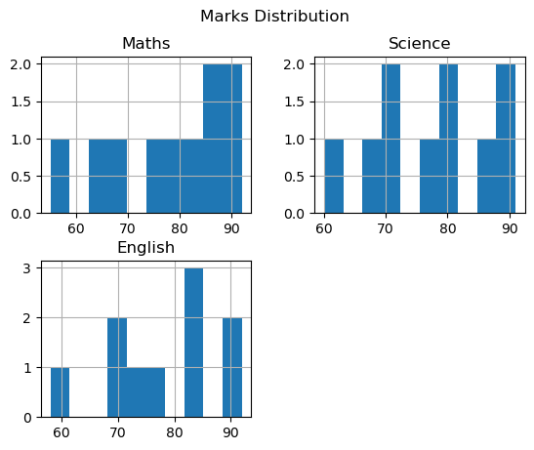

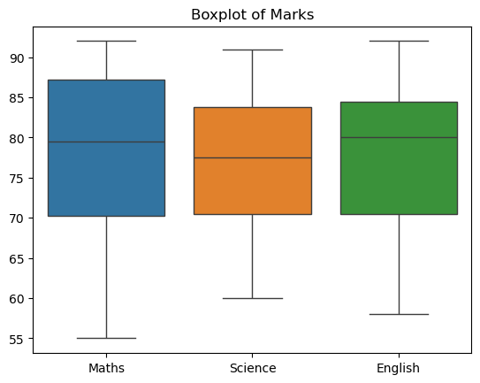

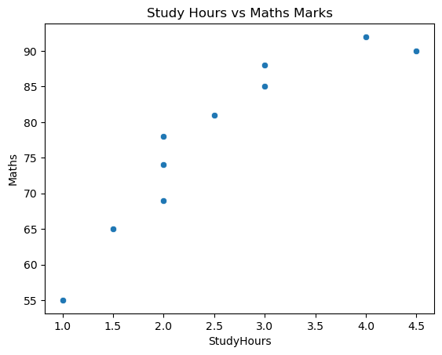

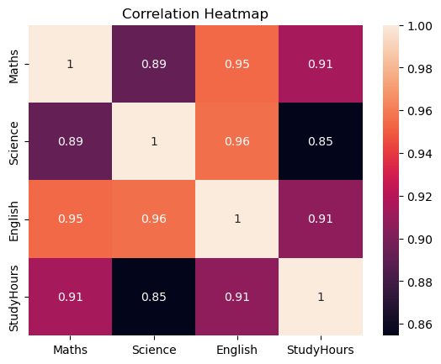

Conclusion: In this experiment, descriptive statistics and multiple data visualizations were performed to understand the structure, distribution, and relationships within the dataset.

Signature of Faculty
EXPERIMENT NO: 10

Title: To compute and interpret statistical measures such as mean, median, mode, range, variance, standard deviation, and interquartile range using Python libraries.

Objective: To understand and calculate basic descriptive statistics from numerical data then implement Python functions using libraries such as NumPy, Pandas, and SciPy for statistical analysis and finally interpret the computed results for better understanding of dataset distribution.
Software Required
- Jupyter Notebook
- Python libraries: NumPy, Pandas, SciPy

Theory:
Statistical measures help summarize and understand the central tendency and dispersion of data. Mean gives the average, median provides the middle value, and mode identifies the most frequent value. Range indicates the spread between the minimum and maximum values, while variance and standard deviation measure how much the data deviates from the mean. The interquartile range (IQR) reflects the spread of the middle 50% of the data and is useful in identifying outliers. These measures provide key insights into the data distribution and are fundamental in data analysis.
Code:
import pandas as pd
import matplotlib.pyplot as plt
d2 = pd.read_csv("pr_10.csv")
d2

print("Mean of the data : ",end="")
print(d2['Salary'].mean())

print("This is median of the Salary : ",end="")
print(d2["Salary"].median())

print("This is the mode of the salary : ",end="")
print(d2["Salary"].mode()) # output will automatically be in ascending order

print("This is the Range of salary for the company : ",end="")
print(d2['Salary'].max() - d2['Salary'].min())

print("Varience in the salary is : ",end="")
print(d2['Salary'].var())

print("The standard deviation : ",end="")
print(d2['Salary'].std())

Q1 = d2['Experience'].quantile(0.05)
Q3 = d2['Experience'].quantile(0.95)
IQR = Q3 - Q1

print("Q1:", Q1)
print("Q3:", Q3)
print("Interquartile Range (IQR):", IQR)

plt.bar(d2["Experience"],d2["Salary"], color="blue")

Output:-
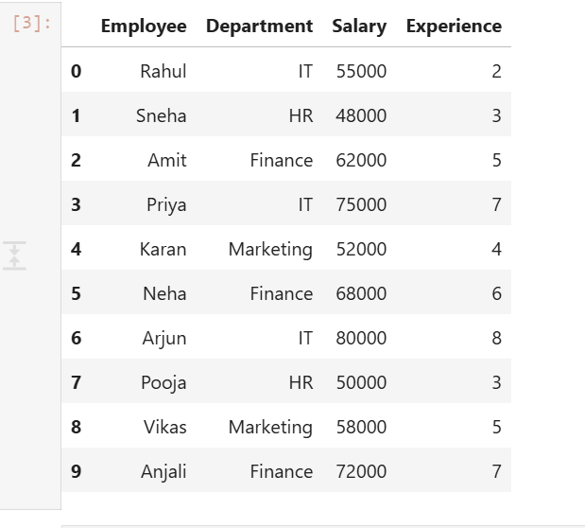

Mean of the data : 62000.0

This is median of the Salary : 60000.0

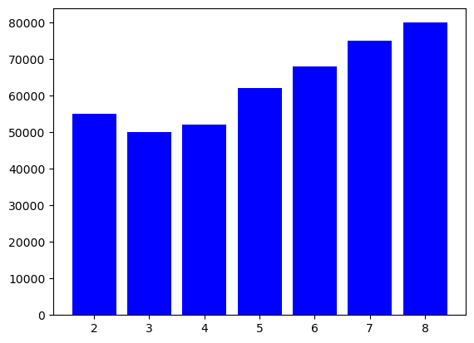

This is the mode of the salary : 0 48000
1 50000
2 52000
3 55000
4 58000
5 62000
6 68000
7 72000
8 75000
9 80000
Name: Salary, dtype: int64

This is the Range of salary for the company : 32000

Varience in the salary is : 126000000.0

The standard deviation : 11224.972160321824

Q1: 2.45
Q3: 7.549999999999999
Interquartile Range (IQR): 5.099999999999999

Conclusion: The experiment successfully computed various statistical measures using Python, offering insights into the dataset’s central tendency and spread.

Signature of Faculty
EXPERIMENT NO: 11

Title: To perform data visualization using a Box Plot to analyze data distribution and detect outliers in Python.
Objective: To understand the concept of box plots and their role in visualizing data distribution, identify quartiles and spread of data using graphical representation. Then detect outliers using box plot visualization in Python.
Software Required:
- Jupyter Notebook
Theory:
A box plot (or whisker plot) is a statistical visualization tool that summarizes data using five main components: minimum, first quartile (Q1), median (Q2), third quartile (Q3), and maximum. It also displays outliers, which are values lying significantly outside the normal range, typically beyond 1.5 times the interquartile range (IQR). Box plots help detect skewness, variability, and extreme observations in the dataset, making them useful for exploratory data analysis.

Code:-

import pandas as pd
import matplotlib.pyplot as plt
import seaborn as sns

d3 = pd.read_json("pr_11.json")
d3

d3.tail()

plt.figure(figsize=(6,4))
sns.boxplot(x=d3['UnitsConsumed'], color="aqua")

plt.title("Electricity Consumption Box Plot")
plt.xlabel("Units Consumed")

plt.show()

Q1 = d3['UnitsConsumed'].quantile(0.05)
Q3 = d3['UnitsConsumed'].quantile(0.95)
IQR = Q3 - Q1

lower_bound = Q1 - 1.5 * IQR
upper_bound = Q3 + 1.5 * IQR

outliers = d3[(d3['UnitsConsumed'] < lower_bound) |
(d3['UnitsConsumed'] > upper_bound)]

print("\nQ1:", Q1)
print("Q3:", Q3)
print("IQR:", IQR)
print("Lower Bound:", lower_bound)
print("Upper Bound:", upper_bound)

print("\nOutliers:\n", outliers)

Output: -
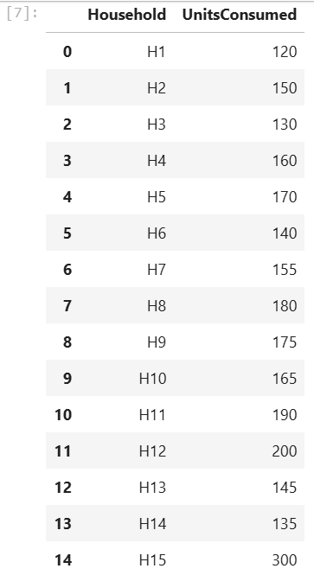

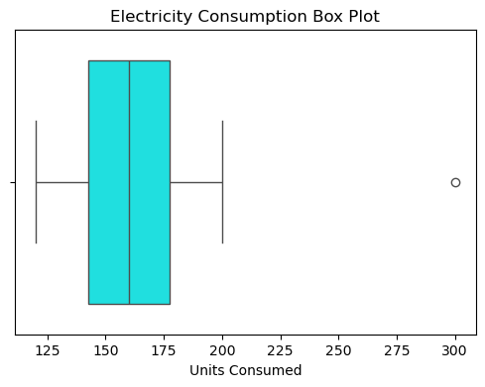

Q1: 127.0
Q3: 229.9999999999999
IQR: 102.99999999999989
Lower Bound: -27.49999999999983
Upper Bound: 384.4999999999997

Outliers:
Empty DataFrame
Columns: [Household, UnitsConsumed]
Index: []

Conclusion: The box plot visualization effectively summarized the data distribution and highlighted the presence of outliers. This method helps analysts quickly interpret variability, skewness, and extreme values, making it an essential tool for exploratory data analysis in Python

Signature of Faculty

EXPERIMENT NO: 12

Title: To compute skewness and kurtosis to understand the shape of data distribution and visualize the distribution using histogram and density plot.

Objective: The objective of this experiment is to analyze the shape and nature of data distribution by calculating skewness and kurtosis, and to interpret the distribution visually using histogram and density plots. This helps in understanding symmetry, tail behavior, and whether the data is peaked or flat relative to a normal distribution.

Software Required: Jupyter Notebook
Theory:
Skewness measures the asymmetry of a data distribution. A positive skew indicates a distribution with a longer right tail, whereas a negative skew indicates a longer left tail. Kurtosis describes the shape of the distribution's tails and peak; high kurtosis indicates heavy tails and sharp peaks (leptokurtic), while low kurtosis suggests light tails and a flatter peak (platykurtic). Combined with histogram and density plots, these measures help assess data normality and detect deviations.
Code: -
import pandas as pd
import matplotlib.pyplot as plt
import seaborn as sns

d4 = pd.read_csv("pr_12.csv")
d4

print("The skewness of data : ")
print(d4["DeliveryDays"].skew())

print("The Kurtosis is : ")
print(d4["DeliveryDays"].kurt())

# this is the Histogram
plt.figure()
plt.hist(d4['DeliveryDays'], bins=8)
plt.title("Histogram of Delivery Time")
plt.xlabel("Days")
plt.ylabel("Frequency")
plt.show()

# Density Plot
plt.figure()
sns.kdeplot(d4['DeliveryDays'], fill=True)
plt.title("Density Plot of Delivery Time")
plt.xlabel("Days")
plt.show()
Output: -

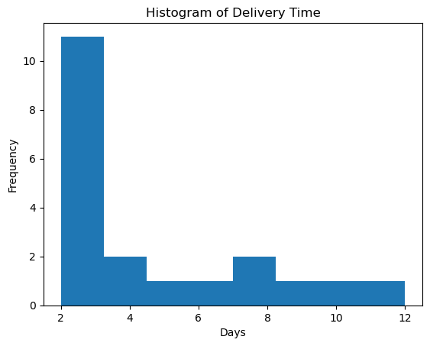
The skewness of data :
1.1896460439622045

The Kurtosis is :
0.3833347183798894

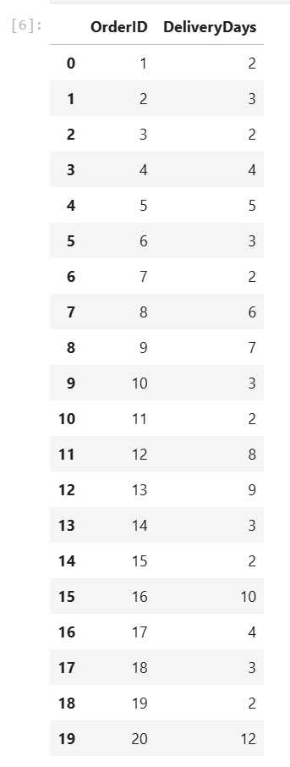
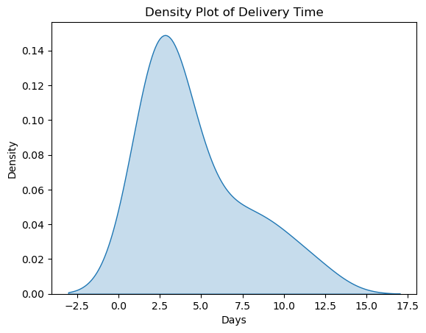

Conclusion: The skewness and kurtosis values successfully provided insight into the symmetry and tail behavior of the dataset. The histogram and density plot visually confirmed the distributional shape, helping in better understanding the nature of the data and assessing whether it follows a normal distribution.

Signature of Faculty

